**CSS Basics**

**Overview**

This project updates your existing project from Lab 1 to add some visual stylistic improvements with CSS.

**Instructions**

1. Use your Lab1-project01.html file from the last lab as a starting point but save it as lab2-project01.html.
2. Create an external style sheet called reset.css that removes all the browser formatting from the main HTML elements and reference inside lab2-project01.html as follows:

*html, body, header, footer, hgroup, nav, article, section, figure, figcaption, h1, h2, h3, ul, li, body, div, p, img*

*{*

*margin: 0;*

*padding: 0;*

*font-size: 100%;*

*vertical-align: baseline;*

*border: 0;*

*}*

1. Create another external style sheet named chapter03-project01.css and include it in your HTML file as well.
2. Add styles to style.css so that it looks similar to that shown in Figure 1. Do not modify the markup within the <body> element.

Be sure to group your style rules together in appropriate commented sections and to make your sizes scalable (i.e., don’t use pixels for font sizes, padding, or margins).

Here’s a hint for the header and footer.

*header, footer {*

*color: white;*

*background-color: #3D6271;*

*margin: 0em 4em 0.5em 4em;*

*}*

* You can make the list items in one line using *display* attribute.
* You will need to make *list-style* equals to None for the navigation bar!
* Do not forget to use the link styling

**Test**

1. Although an exact match is not required, see how closely you can make your page look like the one in Figure 1. Be sure to test in multiple browsers and at different browser widths.

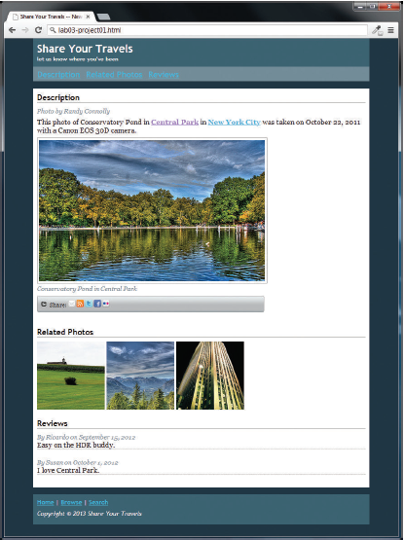

Figure 1 Completed Answer